DIGITAL LITERACY

VITyarthi Project

Name: Rudra Mishra
Registration Number: 25BAS10052
Faculty: Dr Kannan

INDEX

SL NO | TOPIC | PAGE
1 | INTRODUCTION | 2
2 | Task-1 | 3
3 | Task-2 | 4
4 | Task-3 | 6
5 | Task-4 | 7
6 | Task-5 | 8

INTRODUCTION

Digital literacy is an essential skill for the upcoming generations, since as we revolutionize in the tech generation with constantly evolving software.

As we move forward with tech building, factors like presentation, portfolio and platoforming becomes essentials as these are core skills required to sustain in this newly driven environment.

Thus, presenting the agenda of this project and tasks.

TASK – 1

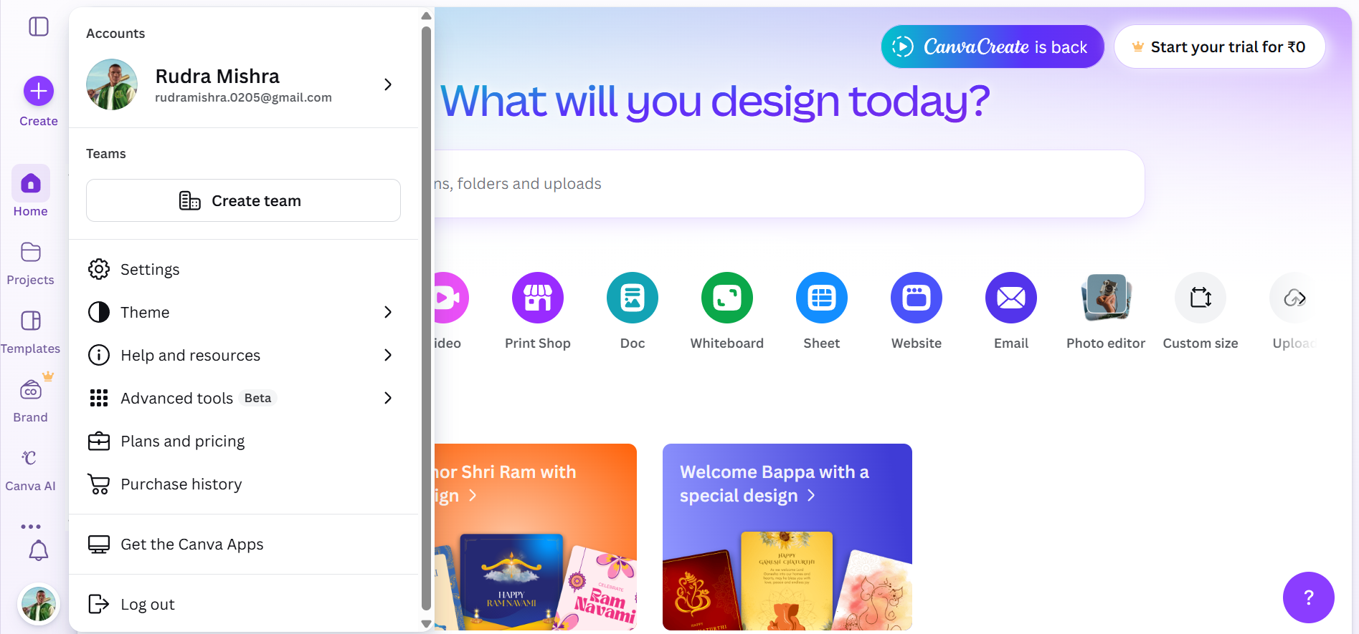
Screenshot of Canva Account

For my presentation, I decided to use Canva because it is such a user-friendly design tool that makes it easy to create something professional-looking, even if you aren't a graphic designer. My project specifically explores the concept of digital literacy, which is essentially our ability to find, evaluate, and share information safely using technology. I wanted my slides to show that being digitally literate isn't just about knowing how to use a computer; it’s about combining those technical skills with critical thinking to stay safe and communicate effectively.
The design covers a few key areas, including essential internet safety rules like using strong passwords and multi-factor authentication, as well as the importance of professional email etiquette. What I found most interesting while putting this together in Canva was how I could take these detailed guidelines, like responding to emails within 24 hours or being cautious with mysterious links and organize them into a clean, visual layout. Using their templates really helped me turn a lot of text into a simple, readable guide that emphasizes how we can all be more responsible and respectful online.

TASK – 2

Required files are attached in /task-2-portfolio

GITHUB REPOSITORY FOR TASK-2:
https://github.com/Bazinga0205/Digital_literacy_25BAS10052_TASK-2

To set myself up for success over the next four years, I’ve chosen to focus on GitHub, LinkedIn, and Stack Overflow. I see GitHub as my digital workshop; it’s where I’ll host my code, practice version control, and eventually contribute to open-source projects to show what I can actually build.

LinkedIn is my professional home base, which I’ll use to connect with mentors, follow industry trends, and build a personal brand that goes beyond just a resume.

Stack Overflow is my go-to for problem-solving; it’s an incredible place to find answers to tough coding bugs and, eventually, a place where I can give back by helping others.
During my first two years, I plan to use GitHub mainly for university assignments and Stack Overflow to help me get through the steep learning curve of new languages. As I move into my third and fourth years, I’ll shift my focus toward my professional presence. I’ll start sharing my milestones on LinkedIn to attract internship opportunities and refine my GitHub profile to act as a portfolio for recruiters. By graduation, I hope to have a solid reputation across all three platforms, transitioning from a student who asks questions to a professional who provides solutions.

TASK-3
To help me grow both technically and academically, I’ve been spending a lot of time on Google Forms and HackerRank. I used Google Forms to practice building structured surveys and quizzes, which taught me how to collect information efficiently and analyze data from different groups of people. On HackerRank, I’ve been diving into coding challenges, focusing on languages like Python and C++. It’s been a great way to take the logic I learn in class and actually apply it to solve tricky, real-world problems.
Looking ahead, these tools are going to be a huge help in my studies. I plan to use Google Forms for research projects and group assignments whenever I need to gather feedback or organize data for a presentation. HackerRank will basically be my "coding gym"—a place where I can keep my skills sharp and prepare for technical exams. By using both, I’m not just reading about technology; I’m actually getting hands-on experience that makes the more difficult academic concepts feel a lot more manageable.

TASK 4

PART-B

A classic example of poor digital communication is when a short, blunt email is sent without any context, leading to a total misunderstanding. Imagine a manager sending a message that just says, "See me in my office now." To the manager, it’s just a quick request to discuss a minor edit on a report. But to the employee receiving it, that lack of detail feels cold and urgent, often triggering a wave of unnecessary anxiety and the fear that they’re about to be fired.
This whole situation could have been avoided with a tiny bit of "digital empathy." Instead of a vague command, the manager could have written, "I just read your report—great job! Do you have a second to chat about a few small tweaks?" This simple change in tone and the addition of a clear subject line completely shifts the vibe. It shows how taking an extra ten seconds to proofread for tone can prevent a lot of stress and keep a working relationship healthy.

TASK – 5

PART-B

While researching digital literacy and cybersecurity, what surprised me most was the sheer sophistication of modern social engineering. I always assumed that staying safe just meant avoiding obvious "spam" emails, but learning how hackers create highly personalized "hook" scenarios like fake internship offers or urgent UPI "collect requests" made me realize how easily anyone can be manipulated. It’s eye-opening to see that cybercrime often relies more on human psychology than complex coding.
As a result, the one habit I’m personally changing is how I handle my UPI transactions. I used to be quite casual about scanning codes or clicking notification pop-ups, but I’ve now committed to the "Golden Rule": never entering my PIN to receive money. I’ve also started auditing my digital footprint regularly to ensure my privacy settings are tight, making sure that what I share today won’t negatively impact my professional future.

THANK YOU

